MAINTENANCE MAP

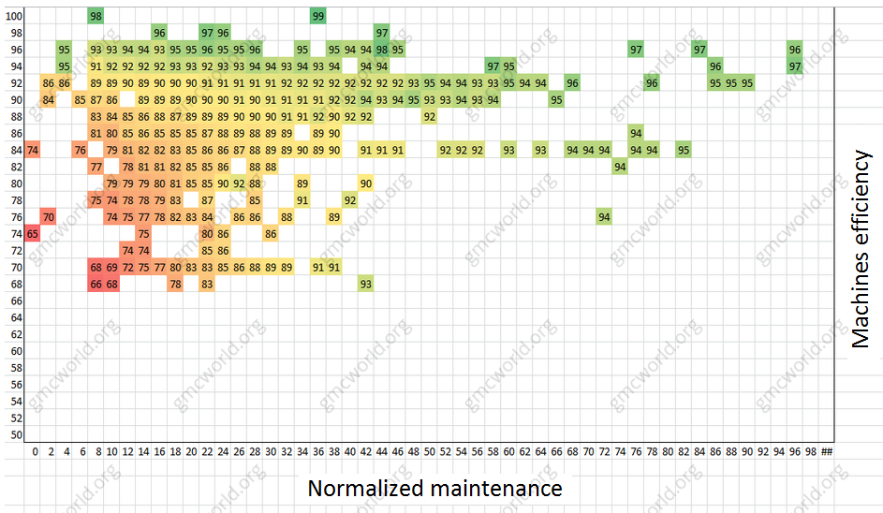

Maintenance (MT) is not the most expensive part in company budget, but can save a couple thousand with proper planning. To do this, you need to invest as much - as you really need and no more.

I failed to find the exact dependence of the machines efficiency with MT, but by analogy with [agents recruiting](https://gmcworld.org/blog/agents-and-distributors-recruitment-map) you can "draw" a map where you will visually see it. Future machines efficiency depends on:

1. Previous machines efficiency.
2. Normalized MT - MT, purified from the influence of machines load and number of shifts. In fact it will MT for one machine at 100% load (5 days) with 1 shift.

Normalized MT = MT in previous period / Number of shifts / (Machine hours / Total possible machine hours * Coefficient)

Coefficient = ratio of total possible machines hours for 7 days to the same number of machines hours for 5 days. In old version GMC simulator ratio is 1.4 to 1 shift and 1.3 to 2 or 3 shifts. In new version GMC simulator ratio is 1.37 for 1 shift and 1.27 for 2 and 3 shifts.

We get clean MT time based on 100% machines load. Also take into account changes in machines efficiency because of purchasing new machines. If you sold some machines, this data is not considered. Calculating the real machines efficiency after buying:

The real machines efficiency = (Machines efficiency in the next period * Machines in the next period - (Machines in the next period - Machines in the previous period) * 100) / Machines in the previous period

This map made from a large number of reports and well demonstrates that the formula of machines efficiency does not change between scenarios. Vertical - machines efficiency in the past period, the horizontal - normalized MT in the past period, the intersection - machines efficiency in the next period.

Hint - machines efficiency limit is achieved in the area of 90-92%, the cost to achieve higher efficiency is not cost-effective. In our [calculation model](https://gmcworld.org/products/calculation-model-v2-pro-version) we calculate optimal investments in MT for each scenario by every period. After trying all possible options (oldschool bruteforce) you will find the best MT plan. For example, in most cases, optimal plan for scenario 12C1 will look like:

1. 1 period - 70
2. 2 period - 50
3. 3 period - 35
4. 4 period - 25
5. 5 period - 2

维修地图



维护（MT）不是公司预算中最昂贵的部分，但可以节省数以千计的适当规划。要做到这一点，你需要尽可能多的投资 - 就像你真正需要的那样，不要再投资。

我没有找到机器效率与MT的确切依赖，但是通过与招聘的代理人的类比，您可以“绘制”一个地图，您可以直观地看到它。未来机器的效率取决于：

1．以前的机器效率。

2．规范化MT – MT，从机器负载和班次数的影响中净化。事实上，一台机器在100％负载（5天），一班班MT。

规范化MT =前一时期的MT / 班次数 /（机器小时数/可能的机器小时总数*系数）

系数= 7天内可能的机器总时间与相同数量的机器小时的比例为5天。 在旧版本的GMC模拟器比例是1.4到1班，1.3到2或3班。 在新版GMC模拟器比例为1.37为1班，1.27为2和3班。

基于100％机器负载，我们得到干净的MT时间。 还考虑到购买新机器时机器效率的变化。 如果您出售了一些机器，则不会考虑这些数据。 购买后计算真机效率：

真正的机器效率=（机器效率在下一个时期*机器在下一个时期 - （机器在下一个时期 - 机器在前一个时期）* 100）/机器在前一个时期

这个由大量报告构成的地图很好地证明了机器效率的公式在场景之间并没有改变。 纵向机器过去一段时间的效率，过去一段时间的横向归一化的MT，下一个时期的交点 - 机器效率。

提示 - 机器效率限制在90-92％的范围内实现，实现更高效率的成本不具有成本效益。 在我们的计算模型中，我们计算每个场景在每个时期的最佳MT投资。 在尝试所有可能的选项（老式暴力）后，您将找到最好的MT计划。 例如，在大多数情况下，情景12C1的最佳计划将如下所示：

1．第1期 - 70

2．第2期 - 50

3．第3期 - 35

4．第4期 - 25

5．第5期 - 2